1. **INTRODUCTION**

* 1. **Overview**

**The Lok Sabha is composed of representatives of people chosen by direct election on the basis of Universal Adult Suffrage. The Constitution of India allows for a maximum of 550 members in the House, with 530 members representing the States and 20 representing the Union Territories. The 17th Lok Sabha was formed by the members elected in the 2019 Indian general election. Elections, all across India, were conducted in seven phases from 11 April 2019 to 19 May 2019 by the Election Commission of India.**

* 1. **Purpose**

**By this project not only presents the data in a visually appealing manner but also provides an interactive experience for readers to explore the intricacies of A Quantitative Analysis of Candidates in the 2019 Lok Sabha Elections. To Extract the Insights from the data and put the data in the form of visualizations, Dashboards and Story we employed Tableau tool.**

1. **PROBLEM DEFINITION & DESIGN THINKING**

**2.1 Empathy Map**

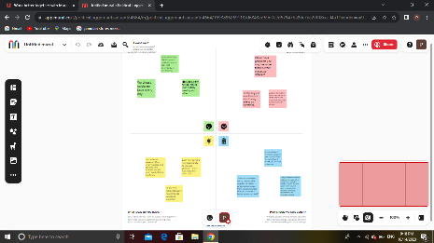

**2.2 Ideation & Brainstorming Map**

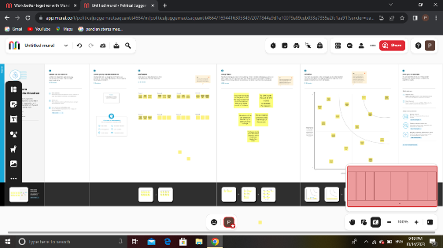

1. **RESULT**

**Output of the Project**

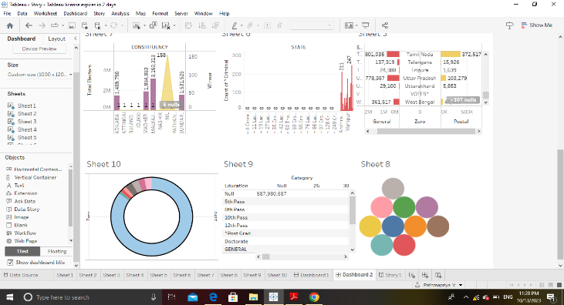

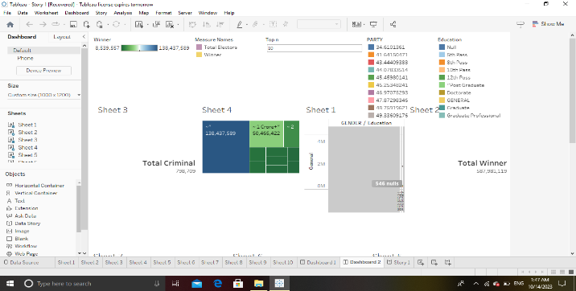

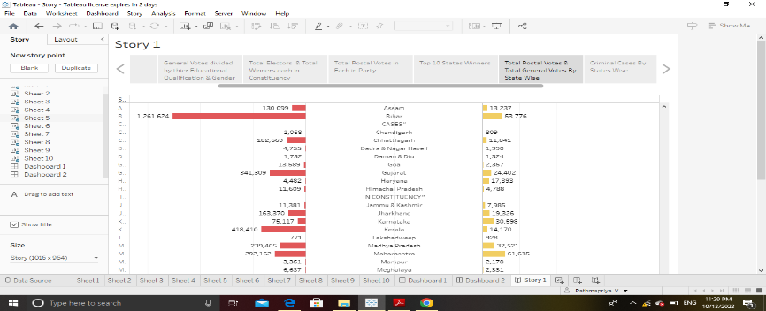

1. **ADVANTAGES & DISADVANTAGES**

**Advantages:**

* **People of India directly choose the member of Lok Sabha so his house is direct representation of people.**
* **Any central government need simple majority to form a government.**
* **If motion of no confidence passed by this house the prime minister and his cabinet need to resign immediately.**
* **The budget is presented in the Lok Sabha by the Finance Minister.**

**Disadvantages:**

* **There is no disadvantages with the Lok sabha. There are some problems like disruption of the proceedings by Congress members and other members. Some members never participate in the debates and proceedings. These members should be admonished to be active in Lok sabha. The rules are too rigid on facts and figures. Many members are afraid to raise issues or make statements due to fear of mistakes in facts. That system should go and members should be allowed to speak from their heart. Whip and party guidelines also stop the expressions of some members. Many improvements are needed there. The most important one is about the No Confidence Motion. The PM is the most powerful person in India. But he is liable to loose confidence every six months. He should be elected by the members of Lok sabha for a full term of five years. The MPs need not be Ministers on regular basis. Professional should be made ministers and should be approved by the Lok sabha as done in USA and other countries. The proceedings of Lok sabha should be regular and for longer period. Then the Lok sabha may fulfill its formation in the country.**

1. **APPLICATIONS**

**Some common types of visualizations that can be used to analyses the performance and efficiency of banks include bar charts, line charts, heat maps, scatter plots, pie charts, Maps etc.**

**5.1 Total Criminal**

**5.2 Total Winners**

**5.3 Gender Votes divided by Educational Qualification & Gender**

**5.4 Total Electors & Total Winners each in Constituency**

**5.5 Total Postal Votes in Each Party**

**5.6 Top 10 State Winners**

**5.7 Criminal Cases By State wises**

1. **CONCLUSION**

**First, we have to understand the given problem. Then, specify the business problem and collect the process of gathering and measuring information on variables of interest, evaluate outcomes and generate insights from the data. Then, download the data and understand the data, connect dataset with Tableau. After, connect dataset with Tableau, preparing the data for visualization involves cleaning the data to remove irrelevant or missing data. This process helps to make the data easily understandable and ready for creating visualizations to gain insights into the performance and efficiency. Then, the number of unique visualizations that can be created with a given dataset. Some common types of visualizations that can be used to analyses the performance and efficiency of banks include bar charts, line charts, pie charts etc. Once created views on different sheets in Tableau, then pull them into a dashboard. The number of scenes in a story for a data visualization analysis of the performance of banks will depend on the analysis and the specific insights that are trying to be conveyed. Then, publish dashboard, story, and reports to tableau public. Once upload was complete, a browser window will automatically open, displaying your published workbook on Tableau Public.**

1. **FUTURE SCOPE**

**My Future scope is nothing but, more features to add on tableau like download option for download the project. Then, it takes more times to open. So, make it is easy to operate.**